**Creating Firstapp:**

Create and run an app with IntelliJ

Run an app from command line

Basics of statement syntax

Line and block of comments

Package and code organization

**Create and run an app with IntelliJ:**

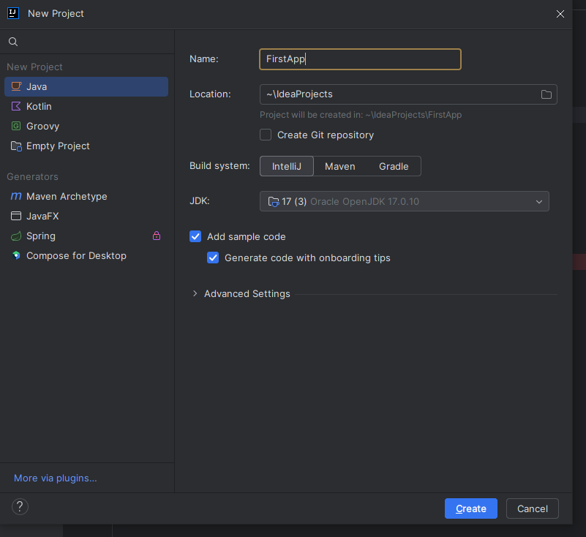

**Sample output console:**

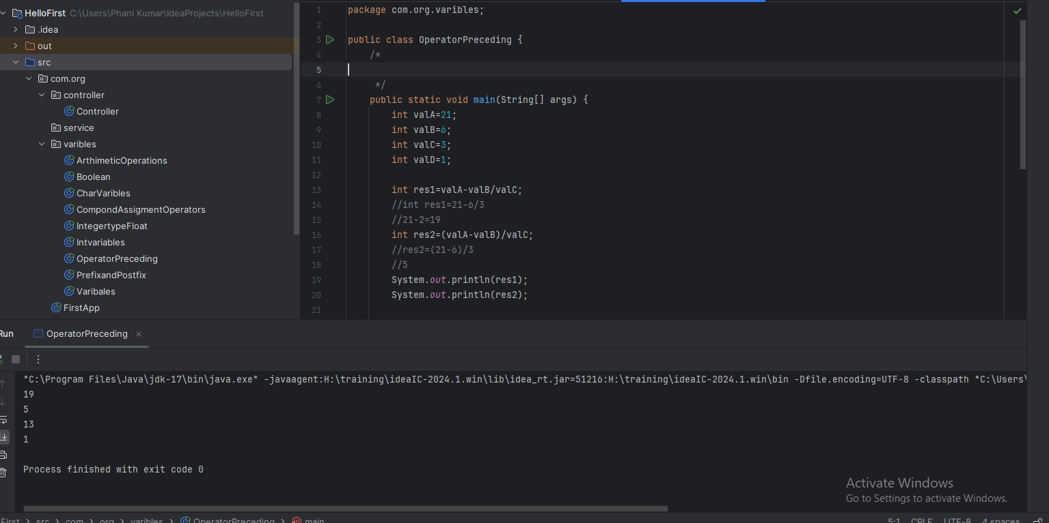

**Basics of statement syntax:**

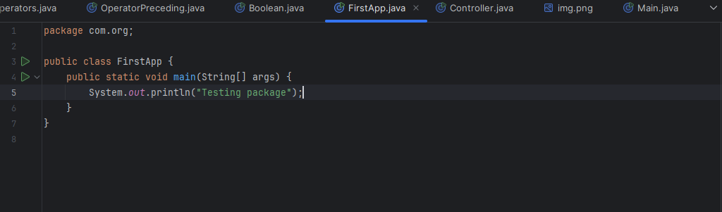

**Line and block of comments**

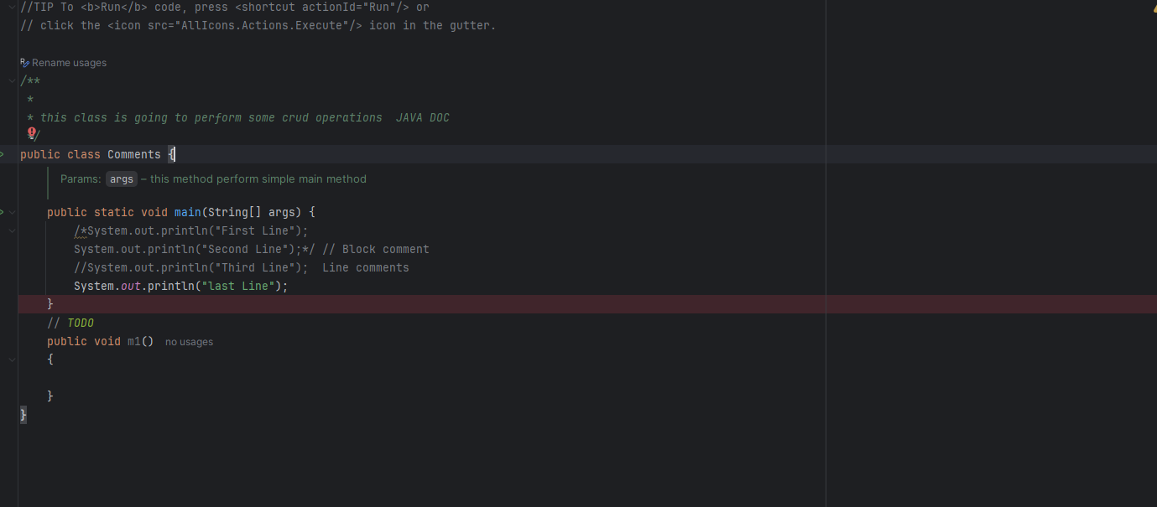

1. **Single line comments (//)**
2. **Block of comments( */ ------/)**
3. **Java doc comments(**/……../)**

**Package example:**

